CombCell
Software Development Plan

Version <1.0>
Jiachen Yang

Revision History
Date | Version | Description | Author
2009/6/23 | 0.5 | Structure, Introduction, Overview | Jiachen Yang
2009/6/24 | 1.0 | Organization. process | Jiachen Yang

Table of Contents
1. Introduction 4
1.1 Purpose 4
1.2 Scope 4
1.3 Definitions, Acronyms, and Abbreviations 4
1.4 References 4
1.5 Overview 4
2. Project Overview 5
2.1 Project Purpose, Scope, and Objectives 5
2.1.1 Primary Objectives 5
2.1.2 Advanced Objectives: 5
2.1.3 Additive Objectives 5
2.2 Assumptions and Constraints 6
2.3 Project Deliverables 6
2.4 Evolution of the Software Development Plan 6
3. Project Organization 6
3.1 Organizational Structure 6
3.2 External Interfaces 7
3.3 Roles and Responsibilities 7
4. Management Process 7
4.1 Project Estimates 7
4.2 Project Plan 7
4.2.1 Phase Plan 7
4.2.2 Iteration Objectives 8
4.2.3 Releases 8
4.2.4 Project Schedule 8
4.2.5 Project Resourcing 9
4.2.6 Budget 9
4.3 Iteration Plans 9
4.4 Project Monitoring and Control 9
4.4.1 Schedule Control Plan 9
4.4.2 Budget Control Plan 9
4.4.3 Quality Control Plan 9
4.4.4 Reporting Plan 9
4.4.5 Measurement Plan 9
4.5 Risk Management Plan 10
4.6 Close-out Plan 10
5. Technical Process Plans 10
5.1 Development Case 10
5.2 Methods, Tools, and Techniques 10
5.3 Infrastructure Plan 10
5.4 Product Acceptance Plan 10

Software Development Plan

Introduction

Purpose
This document defined the whole developing plan of the project CombCell. The plan included activities in terms of phrases, iterations, schedules, and process management. This plan is to provide a specific develop schedule for the project CombCell to guide and control the process during develop.

Scope
The plan is limited in the development and distribution of the project CombCell. All the code source and development documents of the project will be written according to this plan. This plan is to obtain the first negotiation with the end user of this project, define the transferring and deploying time.

Definitions, Acronyms, and Abbreviations
Abbr. | Stands for…
Plan | Refer to this document
SDP | Software development plan, i.e. this document
IIP | Inception Iteration Plan
EIP | Elaboration Iteration Plan
CIP | Construction Iteration Plan
TIP | Transition Iteration Plan
SRS | Software Requirement Specification
CC | CombCell, refer to the project
comb | Actually all ‘comb’ in this document stands for honeycomb
cell | All cells in this document refer to the cell on a honeycomb
CSV | Comma separated values, a kind of data format supported by Microsoft Excel
UI | User-interface, all UI in this document means graphic user interface
SVN | Subversion, refer to http://202.120.40.121/svn/ssp2009/07/5070379022

References
CombCell Inception Iteration Plan
CombCell Elaboration Iteration Plan
CombCell Construction Iteration Plan
CombCell Transition Iteration Plan
CombCell Software Request Specification
CombCell Usecase Document

Overview
This plan will provide the overview and organization of the project, and the plans for the project from management, technical and supporting.

Project Overview

Project Purpose, Scope, and Objectives

Primary Objectives
The project CombCell aims to accomplish an algorithm about calculating length between two cells on a comb. Providing a comb, the algorithm firstly marked each cell an index number. The first index cell (with index 1) is random selected. Other indexes are according to clockwise selection. A comb with 87 cells may look like:
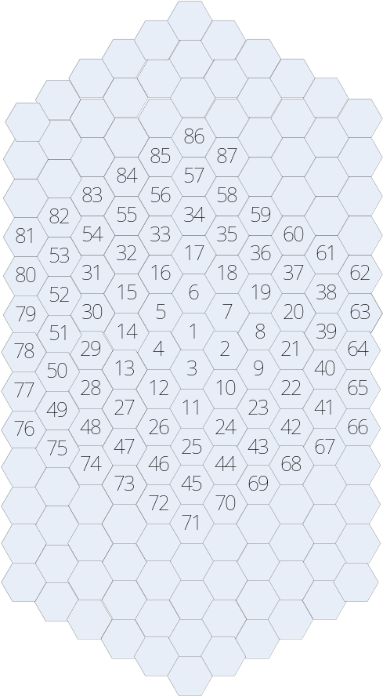
After marked all cells with indexes, the user can use a number to indicate each cell.
User select two cells by click, the algorithm will give a shortest path between these two cells. The length of a path is calculated by the number of cells the path passed through. For example, the path between 9 and 13 in above comb may be 9-2-3-4-13, the length of which is 4 moves.

Advanced Objectives:
- Compare several different algorithms to give a shortest path.
- Show the shortest path on the displayed comb.
- Provide a manually rotatable 3D view of the comb.

Additive Objectives
- Animated all displayed items, better control feedbacks. Smooth changing between 2D display and 3D display.
- Some of the cells are inaccessible.
- Some of the cell-walls are too thick to pass through.
- Several object cells, give a shortest Hamilton path or Hamilton circle.
- Import/export solution with different formats such as xml, csv. Export generated graph.
- CC should have capability with different kinds of operating systems, as Linux/Unix.

Assumptions and Constraints
The project must be fully constructed before the beginning of next semester (Sep.6th ).
A full function prototype should be available by July 31st

Project Deliverables
- Project Vision
- Usecase document
- Glossary
- Requirement Specifications
- Creative Design Briefs
- User Guide / Help Document
- Design Model
- Software Architecture Document
- Test Package
- Deployment Package
- Test Summary
- Function Presentation

Evolution of the Software Development Plan
This plan will be updated prior to be start of each subsequent phase or iteration. The target dates for the end of each phase are shown below.
Version | Phase | Deadline
0.1 | Inception | 2009-6-26
0.2 | Elaboration | 2009-7-3
0.4 | Construction_1 | 2009-7-10
0.6 | Construction_2 | 2009-7-17
0.8 | Construction_3 | 2009-7-24
1.0 | Transition | 2009-7-31

Project Organization

Organizational Structure
The project is a single project with only one developer.
The user is figo2080@gmail.com
The manager is guojian54@163.com

External Interfaces
No external interfaces is included.

Roles and Responsibilities
Role | Responsibilities
Main developer | Analyze, design, code, test
User | Provide requirement suggestions
Manager | Monitor the process

Management Process

Project Estimates
The project should least for 6 weeks from Jun. 23rd to July 31st. The deadline for each phase is listed in 2.4.
Currently the estimation is based on the guide provided by the user, this may be impropriate for the project.
The plan should be re-estimated after each phase according to the finished.

Project Plan

Phase Plan
The development of the will be conducted using a phased approach where multiple iterations occur within a phase. The phases and the relative timeline is shown in the table below:
Phase | Iterations count | Start | End
Inception Phase | 1 | 2009-6-23 | 2009-6-26
Elaboration Phase | 1 | 2009-6-27 | 2009-7-3
Construction Phase | 3 | 2009-7-4 | 2009-7-24
Transition Phase | 1 | 2009-7-25 | 2009-7-31
The milestones that mark the end of each phase can be seen in the table below.
Description | Milestone
Inception Phase | The Inception Phase will develop the product requirements. The high level Project Plan will be developed.
Elaboration Phase | The Elaboration Phase will analyze the requirements and will develop the architectural prototype and UI prototype. At the completion of the Elaboration Phase all use cases selected for Release 0.2 will have completed analysis and design. In addition, the high risk use cases for Release 0.4 will have been analyzed and designed. The architectural prototype will test the feasibility and performance of the architecture that is required for Release 0.2. The Architectural Prototype Milestone marks the end of the Elaboration Phase. This prototype signifies verification of the major architectural components that comprise the R1.0 Release.
Construction Phase | During the Construction Phase, remaining use cases will be analyzed and designed. The Beta version for Release 1.0 will be developed and distributed for evaluation. The implementation and test activities to support the R1.0 releases will be completed. The R1.0 Operational Capability Milestone marks the end of the Construction Phase. Release 1.0 software is ready for packaging.
Transition Phase | The Transition Phase will prepare the R1.0 releases for distribution. It provides the required support to ensure a smooth installation including user training. The R1.0 Release Milestone marks the end of the Transition Phase. At this point all capabilities, as defined in the Vision Document, are installed and available for the users.

Iteration Objectives
Phase | Iteration | Description | Associated Milestones | Risks Addressed
Inception | Preliminary Iteration | Defines product requirements and project plan . | SRS | Clarifies user requirements up front.  Develops realistic project plans and scope.
Elaboration Phase | Develop Architectural Prototype | Completes analysis & design for all use cases. Develops the architectural prototype. | Architectural Prototype | Architectural issues clarified.  Technical risks mitigated.  Early prototype for user review.
Construction Phase | C1 Develop Beta | Implement and test use cases to provide the Beta Version. | Beta | All key features from a user and architectural prospective implemented in the Beta.  User feedback prior to release of software.
 | C2 Develop initial Release | Implement and test remaining use cases, fix defects from Beta, and incorporate feedback from Beta.  Develops the initial system. | Software | Software fully reviewed by user community.  Product quality should be high.  Defects minimized.  Cost of quality reduced.
 | C3 Develop full Release | Incorporate enhancements and defects from initial release.  Develops the full system. | Software | Quick release addresses customer satisfaction.  All key functionality provided in System by full Release.
Transition phase | Software Release | Package, distribute, and install Release. | Software Released

Releases
At the end of last 5 iterations, a release version will be generated.
Phase | Release
Elaboration | Prototype release
C1 | Alpha release
C2 | Beta release
C3 | Full function release
Transition | Final release

Project Schedule
Version | Phase | Deadline | Release
0.1 | Inception | 2009-6-26
0.2 | Elaboration | 2009-7-3 | Prototype release
0.4 | Construction_1 | 2009-7-10 | Alpha release
0.6 | Construction_2 | 2009-7-17 | Beta release
0.8 | Construction_3 | 2009-7-24 | Full function release
1.0 | Transition | 2009-7-31 | Final release

Project Resourcing

Staffing Plan
All plan is executed by main developer described in 3.3.

Resource Acquisition Plan
No resource are needed.

Training Plan
No training program is included.

Budget
Free of charge.

Iteration Plans
Refer to 4 iteration plans for details.

Project Monitoring and Control

Schedule Control Plan
The progress will be reported daily through email.
Each submit of code will be logged in trac system.

Budget Control Plan
No Budget

Quality Control Plan
Before each commit to SVN, the code must be compiled with no error and no warning.
After each compiling, a manual test will be applied on the newly changed functions.
A recursion test will be applied before sending daily report.
A system test will be applied after each generated iteration release.
A deployment test will be applied after full function release and final release.

Reporting Plan
Daily report about the process every day
Log message and issue tracking by each commit of SVN
Iteration Accession report

Measurement Plan
Effort and time will be used to track progress of the project. Planned vs. Actual reports will be used by the project manager to measure progress.
Line counting tool will be introduced to count actual effort.

Risk Management Plan
Risk management will be planed during the elaboration interation.

Close-out Plan
Project deliverables will be archived to the Knowledge Management repository for future reference.

Technical Process Plans

Development Case
Refer to Usecase document

Methods, Tools, and Techniques
Most standards of RUP will be introduced.
Some of the standards of XP will be introduces.
Programming style standards will be according to .Net Framework Guidelines

Infrastructure Plan
No other infrastructure is needed.

Product Acceptance Plan
Acceptance will be argument between user and developer.

